MOLECULAR BIOLOGY
8.L.5

Lipid  (8.L.5.2) | Nutrients that provide energy and material for growth | 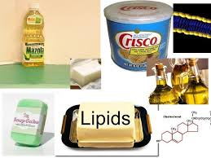
Protein  (8.L.5.2) | Molecules that serve as a food source supplying amino acids to the body that aid as structural components of body tissues like muscle, hair, and collagen | 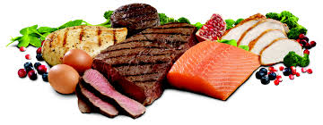
Carbohydrate  (8.L.5.2) | Substances ( such as a starch or sugar) that is rich in energy and is made up of carbon, hydrogen, and oxygen | 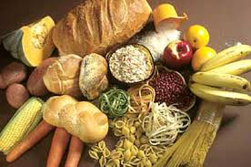
Calorie  (8.L.5.2) | A quantity of food capable of producing energy | 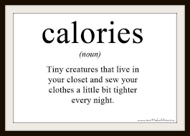
Digestion  (8.L.5.2) | The process in living organisms of breaking down ingested food into easily absorbed substances | 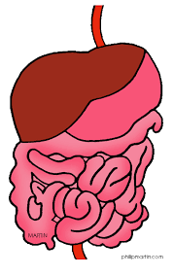
Metabolism  (8.L.5.2) | the sum of the physical and chemical process in an organism where substances are produced, maintained, and destroyed and energy is made available | 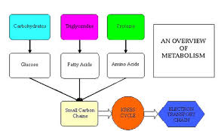
Basal  Metabolic  Rate  (8.L.5.2) | The rate at which energy is used in base condition; Based on average energy levels,  not resting and not exercising | 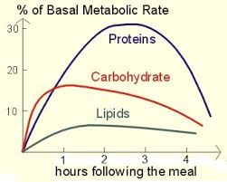
Sedentary  (8.L.5.2) | (of a person) tending to spend much time seated; somewhat inactive.
Mitosis  (8.L.5.1) | Parent cell divides to form two new cells called daughter cells | 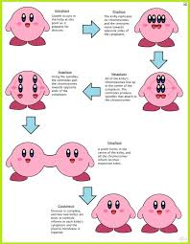
Meiosis  (8.L.5.1) | The process that produces gametes | 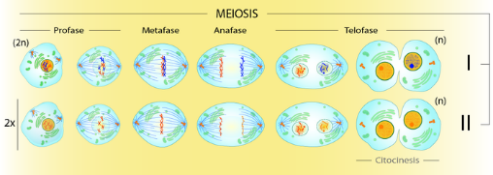
Glucose  (8.L.5.1) | A major energy source in metabolism; sugar | 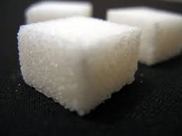
ATP  (8.L.5.1) | Serves as a source of energy for reactions such as muscle contraction | 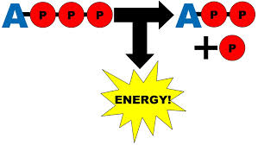
Cellular  Respiration  (8.L.5.1) | The process by which cells break down sugar to release stored energy | 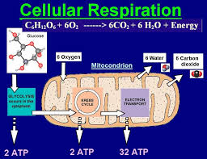
Photosynthesis  (8.L.5.1) | Process in which the cells of plants and other organisms use the energy of sunlight to make food | 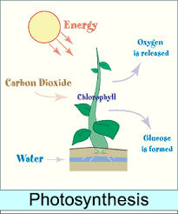
Eukaryote  (8.L.5.1)  Prokaryote  (8.L.5.1) | Organisms whose cells have a nucleus and organelles  Organisms whose cells lack a nucleus and membrane bound organelles | 